- WORK HABITS CRITERIA (A "G, S or N" will be reported for all subject areas each term. Please visit the KLO "Work Ethic" Rubric through the following link:

- http://www.klo.sd23.bc.ca/About/Grading/WorkEthic/Pages/default.aspx

General descriptions for each are outlined below.
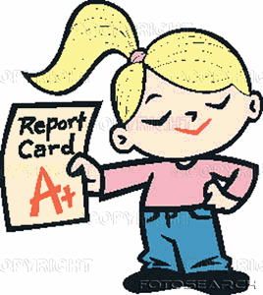
G
-I display good work habits and effort in all I do
-I arrive to class on time, prepared with all supplies, notebooks, binder and other subject related materials
-All my work (at home and in class) is completed to the best of my ability
-I am careful to meet all deadlines, and keep my notebooks up-to-date and in good order
-During class I am attentive and focused on the various tasks, assignments and projects
-I work well in individual and group situations, and I appear to be doing my best
-I am always willing to participate and share my ideas

S
-I display satisfactory work habits and effort most of the time
-I usually arrive in class on time, and am prepared with all my supplies, notebooks, binder and other materials
-Most of my work (at home and in class) is completed to the best of my ability
-Although I occasionally miss handing in an assignment, I am making a good effort to meet deadlines
-I am doing my best to keep my notebooks up-to-date and in good order
-During class I am attentive and focused on the various tasks, assignments and projects, with only occasional lapses.
-I work fairly well in individual and group situations, and on most occasions, appear to be doing my best
-I am willing to participate and share ideas.

N
-My work habits need to improve
-I frequently arrive unprepared for class.
-I sometimes miss my supplies, notebooks, binder or other materials
-On occasion, I am reluctant to put forth the effort to keep my materials and assignments organized
-My homework or assignments are often incomplete or poorly done.
-During class, I am often unfocussed and easily distracted
-I rarely participate in class discussions.

