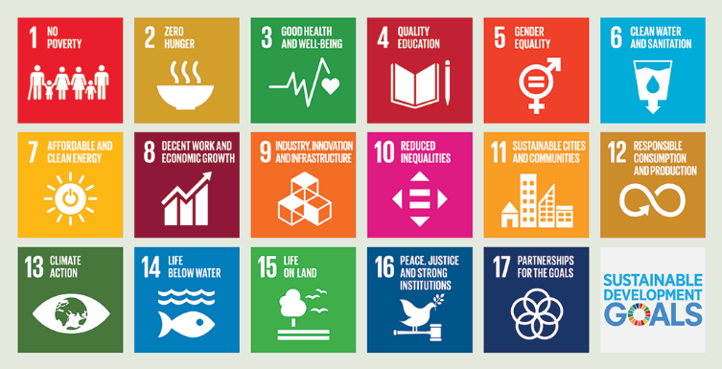
1 No Poverty  Zaya  Gia | 2 Zero Hunger  Caitlyn  Brayden | 3 Good Health & Well Being  Nevaeh  Mohamed | 4 Quality Education  Gaby  Isaiah | 5 Gender Equality  Genesis  Anna | 6 Clean Water  Alex  Asher
7 Affordable & Clean Energy  Diego  Addie | 8 Decent Work & Economic Growth  Julia | 9 Industry, Innovation & Infrastructure  Demitri  Josh | 10 Reduced Inequalities  Kailei | 11 Sustainable Cities & Communities  Andres  Waylon | 12 Responsible consumption & Production  ???
13 Climate Action  Ryder  Erika | 14 Life Below Water  Riley  Sam | 15 Life On Land  Cole  Marie | 16 Peace, Justice & Strong Institutions  Hunter  Martin | 17 Partnerships for the Goals  Mrs. Samaddar | UN Sustainable Goals  Team Samaddar
9 People to Place

