The Raymer Ravens Weekly Mental Wellness Tasks
Week of April 20-24, 2020

Wow! How our lives have changed from a few short weeks ago. I want to remind you to take care of yourself and remember that we are here for you!
Choose at least 5 things from the list provided to help you to stay happy and healthy while you are not at school.
Practice Lazy 8 Breathing  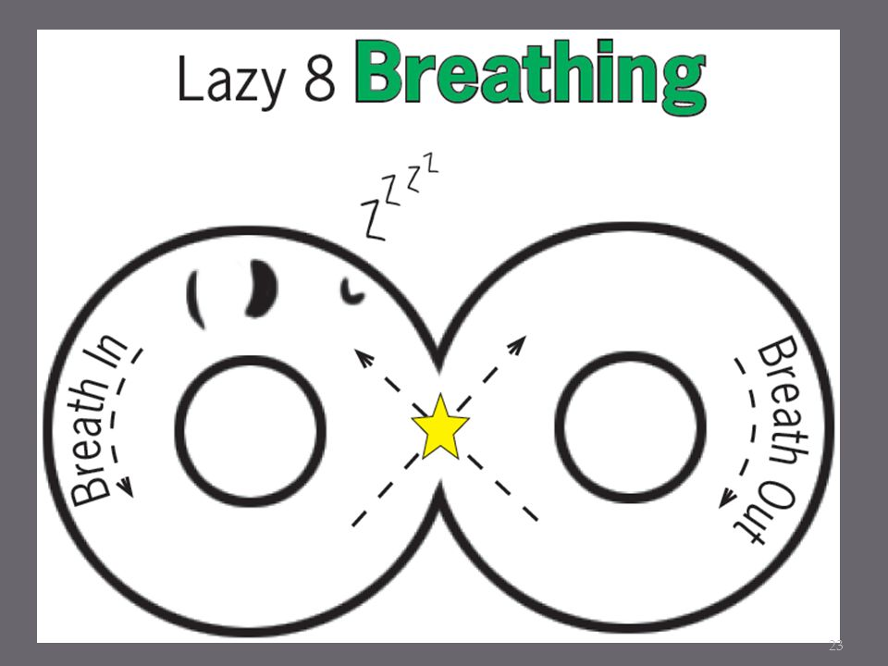 | Go for a walk and notice 5 things you see in nature | Watch Michael Rosen perform We’re Going on a Bear Hunt  https://www.youtube.com/watch?v=0gyI6ykDwds
Declutter your bedroom | Mindfulness Activity: Be the Pond with Cosmic Kids Yoga  https://www.youtube.com/watch?v=wf5K3pP2IUQ | Facetime a relative
Write in a journal how  you are feeling | Help make a meal in your home | Write down all the people in your life that are there to support you

"You're braver than you believe, stronger than you seem, and smarter than you think" – A.A Milne

Miss. May
School Counsellor
Raymer Elementary

