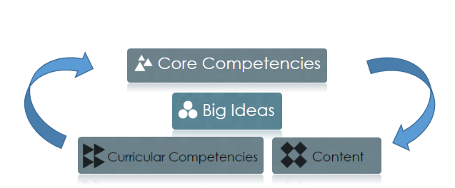

**Planning Overview**

**Content**

**Curricular Competencies**

**Big Idea(s)**

**Essential Inquiry Question(s)**

**I can statements (Learning Targets)**

**Core Competency/Competencies**