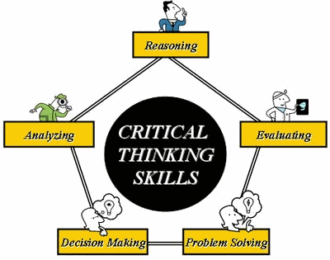

The glue that holds a class together is "thinking" - thoughtful teachers and thoughtful students.

The ultimate goal is to help you (students) develop as thinkers to use your knowledge to problem solve, to act wisely. Our goal is for you to see yourself as a successful learner!

In our class you will find diverse students with a wide range of abilities. It is important we do our best to address and support the learning needs of all students in our class. You can expect instructional strategies that will draw from different frameworks and approaches together to create the best of teaching and learning.

To support all learners, you will notice instruction will follow a pattern called the "gradual release of responsibility":
- model
- guided practice
- independent practice
- independent application

You will be given opportunities to monitor your use of thinking strategies in gradual release and will be asked to make links between how and why they are used in different tasks and settings.

In addition, opportunities will be built into class time for you to assess your own thinking and learning against shared criteria. This is one of the most effective ways to help you think about your own thinking (metacognition).

Too many students have been heard to say, "Just help me get this assignment done. Don't teach me!" Ultimately, we would like to see you learn to use metacognition to make and monitor your own personalized plans for growth (PPG's). Again, see yourself as a learner!

You will:

-have opportunities to work both alone and in collaboration with others (e..g, paired and group structures)
-understand all ideas are welcome; all students belong in the regular classroom
-be provided more time or more specific teaching when required to reach the curricular outcomes
-build and increase relevant skills such as how to sunthesize the key ideas from information text ("not just get through stuff")
-apply critical skills independently
-have a variety of texts (e.g., not be tied to one text book, participate in literature/information circles)
-have opportunities to write intensively (e.g., generate ideas and to link these ideas through writing); not just rote copying or filling in quick answers, but using writing strategies, summarization, collaborative writing, establishing specific product goals, word processing, senence combining, pre-writing, inquiry, process writing, studying models of writing, and writing across the content areas
-use technology (not just simply as a pencil, but a means of accessing, demonstrating, and expanding thinking)
-be involved with ongoing formative assessment (see AFL)
-have extended time for literacy (e.g., "10,000 hour rule" Malcolm Gladwell, 2008 - see p. 15 It's All About Thinking)

Ask yourself:

What am I able to do, considering the criteria for success?
What is missing? or What do I need to learn?
What is my plan for learning?
Who can help me?

AFL strategies you will understand and use:
1. Learning intentions (Learning Destination / Learning Outcomes)
2. Criteria
3. Descriptive feedback
a) What's working?
b) What's not working?
c) What's next?
4. Questioning
5. Self-assessment and peer assessment
6. Ownership

You will experience 6 well-known inclusive teaching practices:
1. assessment for learning (see above)
2. open-ended strategies
3. gradual release of responsibility
4. cooperative learning
5. literature circles and information circles
6. inquiry

Key beliefs about teaching and learning:
-learning is both individual and social
-learning should be personally meaningful and authentic
-learning builds from prior experience and background knowledge
-students, grades 5-12, must learn to work with a range of different teachers w ho may use different instructional styles and may convey different messages
-students, grades 5-12, must learn subject content and the subject-related thinking strategies to engage with, remember to connec to, process, and synthesize the content

Resource: It's All About Thinking : Collaborating to Support All Learners in English, Social Stuides, and Humanities, Faye Brownlie and Leyton Schnellert, 2009)

Follow Up Strategies To Deepen Your Thinking (Tomlinson/McTighe, 2006)
¢Remember "Wait Time I & II" – after question; after response
¢Call on students randomly (Note to self – cue cards, popsicle sticks)
¢Use probes and follow-ups?
¢Cue responses to open-ended questions
¢Ask students to "unpack their thinking"
¢Periodically ask for summaries
¢Play devil's advocate
¢Survey the class
¢Pose metacognitive/reflective questions
¢Encourage student questioning
¢Use think-pair-share

